QUESTIONNAIRE for Students

‘Speaking the Studio’: Exploring Gaps in Student Understanding of Photographic Studio Language.

This study is part of my research on the PgCert Academic Practice at UAL.
As part of this project, I aim to explore what MA Fashion Photography students already know, and what they may find challenging, about photographic studio terminology. Students enter the workshops with diverse educational, linguistic, and technical backgrounds, and this can affect their confidence, communication, and ability to work independently.
My research will analyse the current challenges students and technical staff experience with photographic studio terminology, focusing on gaps in understanding, confidence levels, and the impact of these on learning. The methodology will be qualitative and exploratory using a responsive evaluation approach. This will consist of a short online questionnaire with photography students and technical staff. Responses will be analysed thematically to identify common needs, gaps in knowledge, and priorities for future teaching support.
Participant Consent Form
You are being invited to take part in a research project. Before you decide to take part, it is important for you to understand why the research is being done and what it will involve. Please take time to read the information sheet carefully and discuss it with others if you wish. Ask if anything is unclear or if you would like more information.
- I understand that I have given my consent to be interviewed about my thoughts on my understanding and use of photographic studio terminology, including my experiences, challenges, and confidence in engaging with studio language.
- I fully give my consent to take part.
- I understand that I have given approval for my opinions to be included in the research outputs. Anything I say may be used in academic papers relating to the project, although these quotations will be anonymous.
- I have read the information sheet about the research project, which I have been asked to take part in and have been given a copy of this information to keep.
- What is going to happen and why it is being done has been explained to me, and I have had the opportunity to discuss the details and ask questions.
- Having given this consent, I understand that I have the right to withdraw from the research programme at any time without disadvantage to myself and without having to give any reason.
- I hereby fully and freely consent to participation in the study, which has been fully explained to me.

About You
- What course and year are you studying?
(Open text)

- Is English your first language? (Optional)

- Yes
- No (Please specify)

- Describe your previous experience with photography or studio work before joining the course:

- A lot of experience
- Some experience
- A little experience
- No previous experience

- Have you previously used photography studios before your studies at LCF?

- Yes
- No
- Not sure

Your Experience in the Studio
- How confident do you feel using photographic studio equipment?

- Very confident
- Confident
- Somewhat confident
- Slightly confident
- Not confident

- How confident do you feel using or recognising studio terminology?

- Very confident
- Confident
- Somewhat confident
- Slightly confident
- Not confident

- When you hear technical terms during workshops, how often do you understand them immediately?

- Always
- Often
- Sometimes
- Rarely
- Never

- If you do not understand a term, what do you usually do?

- Ask the technician/tutor
- Ask a peer
- Search online
- Search LCFTech SharePoint pages
- Guess based on context
- Avoid asking because I feel embarrassed
- Other (please specify)

Identifying Equipment
The below questions are not a test, but simply a way to better understand existing familiarity with terminology.
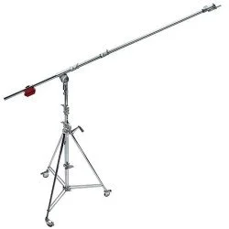
- Image 1: What is this piece of equipment called?
(Short answer)

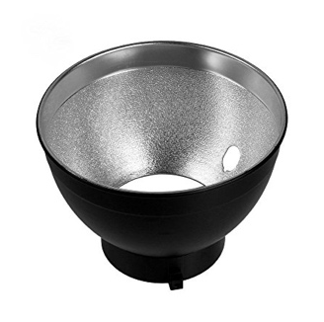
- Image 2: What is this lighting modifier called?
(Short answer)

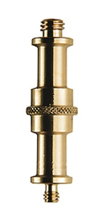
- Image 3: What is this studio tool called?
(Short answer)

- Have you used any of the equipment shown?
- Yes
- No
- Not sure

Understanding Your Needs
- What do you find most challenging about learning studio terminology?
(tick all that apply)
- Remembering unfamiliar words
- English not being my first language
- Too many new terms introduced at once
- Not enough time to practice
- I feel nervous asking questions
- Terminology differs from what I learned previously
- Other (please specify)

- What forms of support would help you learn studio terminology more effectively? (tick all that apply)

- Demonstrations
- Visual guides with images
- Printed sheets or reference cards
- Short video explanations
- A glossary (digital or printed)
- Peer learning
- Independent practice time
- Other (please specify)

- Does terminology affect your confidence in the studio? If yes, how?
(Short answer)

Future Possibilities
- Would a centralised glossary help you feel more confident in the studio?

- Yes
- Maybe
- I’m not sure
- Probably not
- No

- If a glossary or resource were created, what should it DEFINITELY include?
(Short answer)

- Is there anything else you would like to share about your experience learning studio terminology?
(Short answer)

