QUESTIONNAIRE for Staff

‘Speaking the Studio’: Exploring Gaps in Student Understanding of Photographic Studio Language.

This study is part of my research on the PgCert Academic Practice at UAL.
As part of this project, I aim to explore what MA Fashion Photography students already know, and what they may find challenging, about photographic studio terminology. Students enter the workshops with diverse educational, linguistic, and technical backgrounds, and this can affect their confidence, communication, and ability to work independently.
My research will analyse the current challenges students and technical staff experience with photographic studio terminology, focusing on gaps in understanding, confidence levels, and the impact of these on learning. The methodology will be qualitative and exploratory using a responsive evaluation approach. This will consist of a short online questionnaire with photography students and technical staff. Responses will be analysed thematically to identify common needs, gaps in knowledge, and priorities for future teaching support.
Participant Consent Form
You are being invited to take part in a research project. Before you decide to take part, it is important for you to understand why the research is being done and what it will involve. Please take time to read the information sheet carefully and discuss it with others if you wish. Ask if anything is unclear or if you would like more information.
- I understand that I have given my consent to be interviewed about my thoughts on students’ understanding and use of photographic studio terminology, including any challenges I observe and the support I feel would be beneficial.
- I fully give my consent to take part.
- I understand that I have given approval for my opinions to be included in the research outputs. Anything I say may be used in academic papers relating to the project, although these quotations will be anonymous.
- I have read the information sheet about the research project, which I have been asked to take part in and have been given a copy of this information to keep.
- What is going to happen and why it is being done has been explained to me, and I have had the opportunity to discuss the details and ask questions.
- Having given this consent, I understand that I have the right to withdraw from the research programme at any time without disadvantage to myself and without having to give any reason.
- I hereby fully and freely consent to participation in the study, which has been fully explained to me.

About Your Role
- What is your role?
  - Specialist Technician
  - Support Technician
  - Technical Coordinator
  - Associate Lecturer / Visiting Practitioner
  - Other (please specify)
- How long have you worked in photographic or media studios?
  - <1 year
  - 1–3 years
  - 3–5 years
  - 5–10 years
  - 10+ years

Your Observations of Student Learning
- In your experience, how familiar do students tend to be with studio terminology when they first arrive?
  - Very familiar
  - Somewhat familiar
  - Not very familiar
  - Not at all familiar
- What terminology do students most consistently struggle with?
(Open text question)

- What patterns or challenges do you notice among students learning studio equipment?
(Tick all that apply)
  - Variation in prior knowledge
  - Lack of hands-on experience
  - Confidence barriers
  - English language barriers
  - Difficulty remembering names
  - Students rely more on peers than staff
  - Other (please specify)

Identifying Student Knowledge (Image-Based Section)
These questions help understand what staff believe students recognise or misidentify.
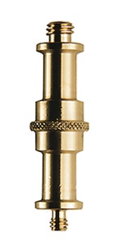
- Image 1: What do you think MOST students call this piece of equipment?
(Short answer)

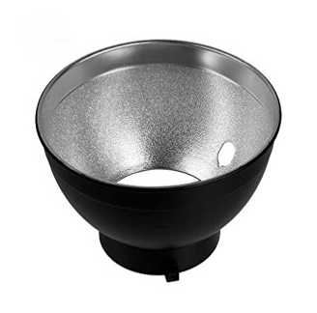
- Image 2:Silver Reflector What do you think MOST students call this modifier?
(Short answer)

- What equipment do students misname most often?
(Open text question)

Teaching, Communication & Shared Language
- Do you feel there is a consistent shared language across the technical team when teaching?
  - Yes
  - Mostly
  - Somewhat
  - Not really
  - No

- Do you notice differences in terminology familiarity related to students’ educational, linguistic, or cultural backgrounds? Please explain.
(Open text question)
- What challenges arise when students don’t understand terminology?
(Open text question)
- What strategies do YOU use to help students learn terminology effectively?
(Open text question)

Future Support & Resource Considerations
- What types of resources do you think would best support students’ understanding of studio terminology?
(Tick all that apply)
  - Visual guides or posters
  - In-class repetition
  - A centralised glossary (digital or printed)
  - Hands-on demonstrations
  - Short video demonstrations
  - Equipment labels
  - Peer learning systems
  - Other (please specify)
- Do you think students would benefit from a shared glossary?
  - Yes
  - Maybe
  - Not sure
  - Probably not
  - No
- What should such a resource (if created) include?
(Open text)
- Any final thoughts on how students could be better supported?
(Open text)

